Laura Zah and Family
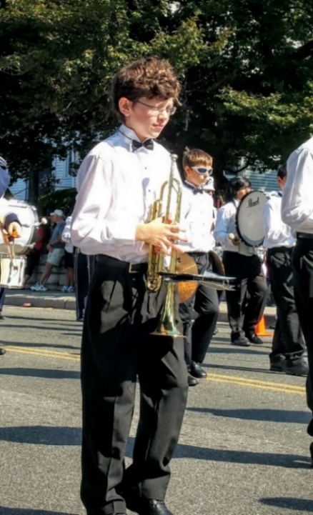
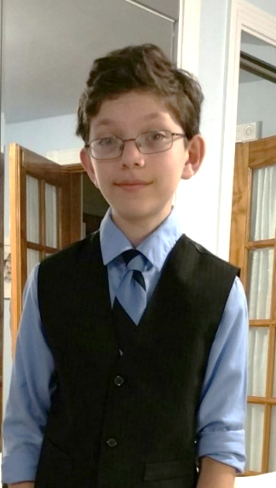
353 Miller Avenue, Sheffield, MA, 01257
Contact Information:
Home Number: 413-229-9075
Cell Number: 413-429-7970
E-mail: laurazah@ymail.com
June 23, 2016
Dear Medical, Research and Genetic Community:
My name is Laura Zah.
I am the mother of a 12-year-old boy, Alexander Zah-Greenspan, recently diagnosed with a rare genetic mutation in the BAG3 gene, specifically a heterozygous mutation in exon 3 that results in a Pro209Leu amino acid substitution. This mutation is associated with myofibrillar myopathy (MFM6) and axonal neuropathy, that results in cardiac and respiratory failure. It is expected to progress rapidly and be fatal in childhood or adolescence. This genetic mutation is a de novo mutation and new in our family.
I appeal to you in hopes of treatment for my son.
My son, Alexander, is lucky to continue to be fully functional and only minimally affected by this unfortunate mutation. He has no clinical signs of heart disease as of now. The echocardiogram last week showed 75% to 80% EF and the EKG only showed minimal nonspecific ST/T Changes. The 24-hour event monitor revealed no abnormalities. He has no cardiac symptoms. The EF two months ago was also 80%.
Alexander does have polyneuropathy that showed on the EMG tests, but again he can still run and jump. The only obvious neurologic sign is his shortening of the Achilles tendon on the right foot; he walks on his toe, with the heel an inch off the ground. He can walk long distances without trouble.
Alexander is very advanced academically, skipped one grade and continues to be in advanced coursework. He is first chair in trumpet and in addition he is part of the high school jazz band. He will soon take part in a national competition of high school bands in Nashville Tennessee. He loves to play Jazz and he happily hums through everything he does.
Our journey for obtaining a diagnosis has been long and challenging, partly because Alexander is doing so well.
We began in 2012 at Baystate Medical Center in Springfield Massachusetts, then to U-mass Medical Center in Worcester, MA. Genetic tests for CMT panel revealed no abnormalities. Later we pursued investigations at Boston Children Hospital. Finally, we were referred to the NIH, where Alexander participated in a research study. There the genetic mutation was identified in 2016. Throughout all this time Alexander’s condition has not deteriorated drastically.
The news of this genetic mutation and its expected outcome, is devastating for our whole family, our school and our community. It is inconceivable that a wonderful boy with such potential in all respects will rapidly decline and likely die.
Our search for treatment and clinical trials, have been nonproductive. I was led to believe that because of the rarity of the mutation, there will likely never be any treatments or therapeutic interventions.
We are fully aware that my son’s condition is extremely complex. At the same time, we hope that the efforts made so far will not be wasted. We have been fortunate to be able to identify his mutation. We are also lucky enough to live in a time of rapid and outstanding genetic and medical advances that could save his life. We are willing to pursue any avenues, to improve his condition.
As a mom and a nurse I am heartbroken.
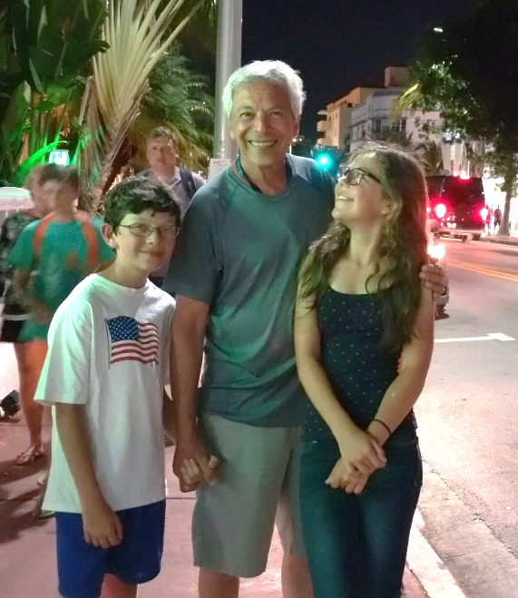
We cannot remain passive and allow my son to perish. We are desperately hoping to be heard by people like you, who can help. Currently, Alexander is living happily and unaffected. Even if Alexander were the only one with this rare disease, he would have the right to live. Developing the appropriate treatment, now, can preserve his quality of live. We must find a way to help Alexander while he is still healthy.
The knowledge gained from developing treatments that will save my son may be used to do the same for others.
Our hopes rest upon you.
What can you do to help?
Our gratitude cannot be sufficiently emphasized for anyone willing to pursue avenues for the treatment and possibly the cure for my son’s condition.
Sincerely,
Laura Zah and Family

